36.47: Let y be the separation between the two points being resolved and let s be their distance from the telescope. Then the limit of resolution corresponds to 1.22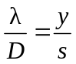
a) Let the two points being resolved be the opposite edges of the crater, so y is the diameter of the crater. For the moon, 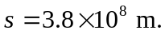
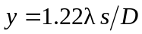
Hubble: D = 2.4 m and 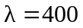nm gives the maximum resolution, so y = 77 m
Arecibo: D = 305 m and 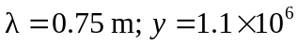 m
b) 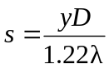
Let 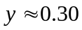(the size of a license plate)

